Investment Analytics BI

**Wireframe Documentation**

**Homepage**

**We have divided Investment Analytics FDI`s BI: -**

**1. Here we can understand underlying pattern of several sectors based on data sources using Tableau**

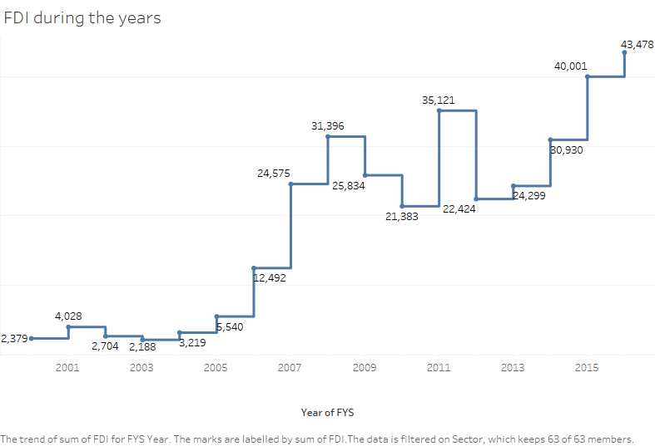

Stakeholders will encounter various graphical patterns in making decision making abilities of investment via FDI routes

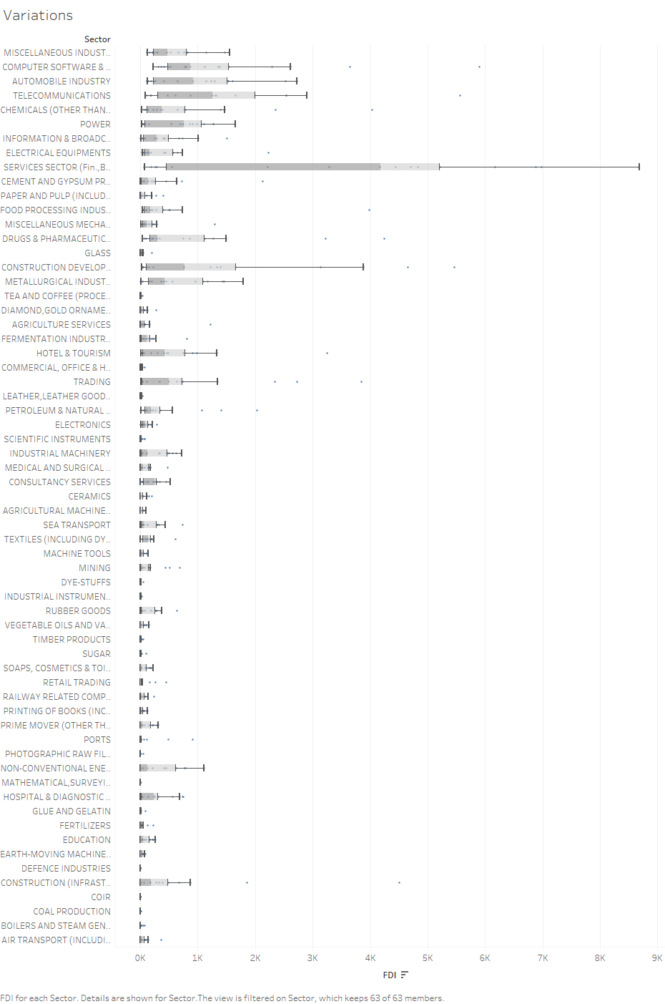

**Based on stakeholders input, our Tableau will recommend trends to User on Homepage itself. A sample view of Homepage showing results is below:**

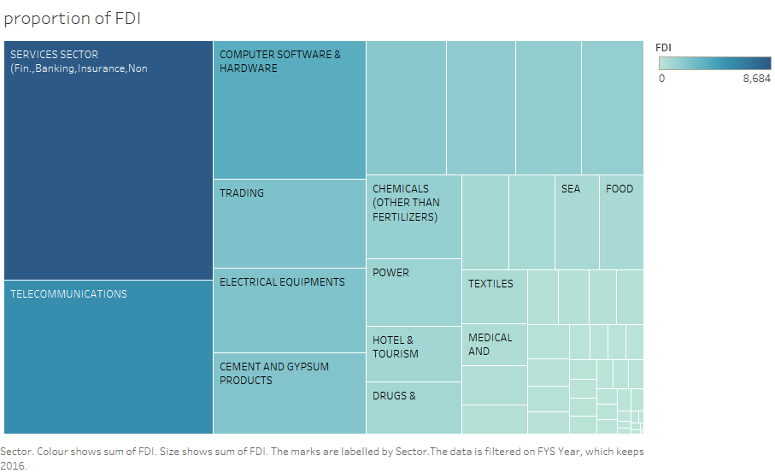

**Variety of Recipes Page**

**In this Page, we will showcase some pattern that might follow of each category for stakeholders to see.**

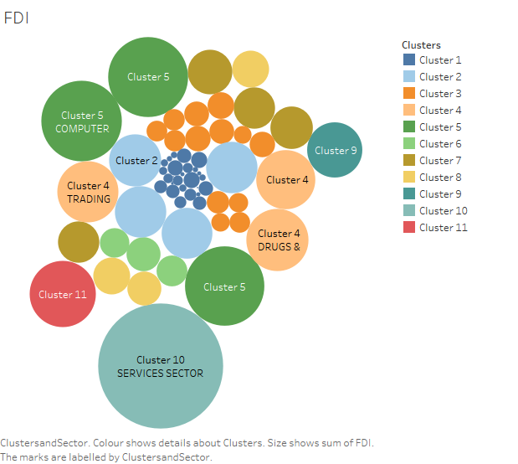

**Detailed Graphical Page**

**This will be the page where trends according to demand will be showcased with full details like the process of making in order to make investment decision judiciously**

